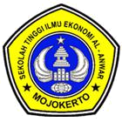
SEKOLAH TINGGI ILMU EKONOMI AL-ANWAR MOJOKERTO

Ijin Penyelenggaraan Berdasarkan SK Menteri Pendidikan dan Kebudayaan RI Nomor : 147/D/O/1998 Tanggal 26 Oktober 1998
Program Studi :
* Akuntansi Terakreditasi BAN PT Nomor : 2267/SK/BAN-PT/Akred/S/IV/2021

 |  | JURNAL PERKULIAHAN SEMESTER GANJIL 2022/2023
Mata Kuliah | : LABORATORIUM AKUNTANSI
Prodi | : S1 Akuntansi |  |  |  | Kelas SORE B - Jam Ke-II
Semester | : 3
PERTEMUAN | TANGGAL |  |  | Berita Acara Perkuliahan
KE-
1 | 2022-09-13 |  | Introduction
2 | 2022-09-20 |  | Accounting in Action
3 | 2022-09-27 |  | The Recording Process for Service Business
4 | 2022-10-04 |  | Adjusting the Accounts for Service Business
5 | 2022-10-11 |  | Worksheet for Service Business
6 | 2022-10-18 |  | Financial Statement for Service Business
7 | 2022-10-25 |  | Completing the Accounting Cycle for Service Business
8 | 2022-11-15 |  | Cases in Trading Business
9 | 2022-11-22 |  | Lanjutan
10 | 2022-11-29 |  | Lanjutan
11 | 2022-12-06 |  | Cases in Manufacturing Business
12 | 2022-12-13 |  | Lanjutan
13 | 2022-11-22 |  | Lanjutan
14 | 0000-00-
 |  |  |  |  | Mojokerto, 17 Februari 2023
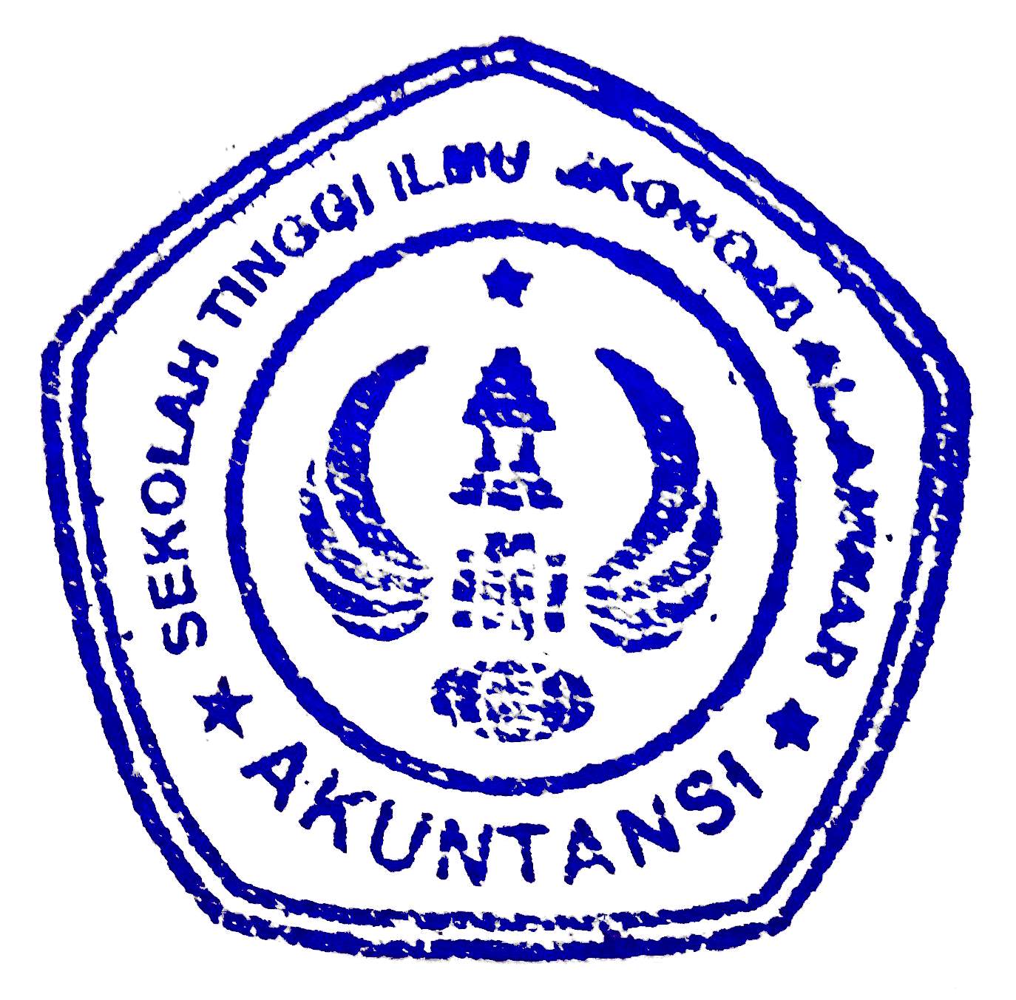 | Kaprodi |  |  |  | Dosen PJMK
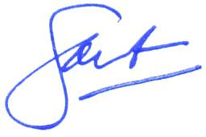



Dr. H. Soesanto, S.TP., M.MT. | Inuk Wahyuni Istiqomah, S.E., M.Si., Ak., CA
NIDN 0707057201 | NIDN 0723087501

